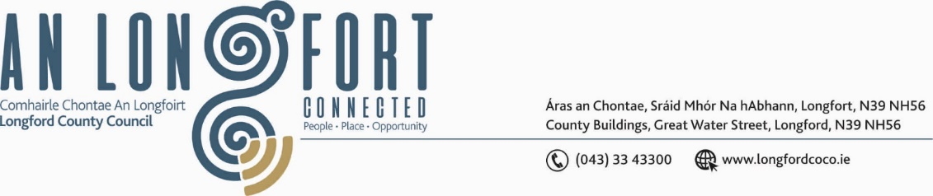

BALLYMAHON MUNICIPAL DISTRICT

Please note meeting will be held via Microsoft Teams and in Ballymahon Library.

15 September 2022.

To: Each Member of Ballymahon Municipal District.

Dear Member,

You are requested to attend a Meeting of Ballymahon Municipal District to be held
in Ballymahon Library and via Microsoft Teams on Thursday 22 September 2022 at 4pm to transact business, as set out on the agenda hereunder.
Yours sincerely,

Ann Marie Mc Keon
_______________
Ann Marie Mc Keon,
Meetings Administrator.

AGENDA

Prayer before meeting.

1. Confirmation of Minutes:

(i) Ballymahon Municipal District Meeting held on the 28 July 2022 – copy enclosed.
(ii) Ballymahon Municipal District Committee Meeting held on the 28 July 2022 – copy enclosed.

2. Matters arising from Minutes.

3. Declaration of Interest by Members.

4. Management Report - enclosed.

5. Consideration of amendment to Ballymahon Standing Orders for commencement time of monthly meetings.
6. Proposed Projects/Expression of Interests.

7. Community Grant Support Scheme 2022 – enclosed.

8. Update on Ardagh Clock Tower.

9. Notices of Motions, submitted by Councillors, as listed hereunder –

Councillor Gerard Farrell
(i) I call on Longford County Council to support the committee from Saints Island graveyard in purchasing a pump-to-pump water for use at family graves.
(ii) I call on Longford County Council to engage with the OPW and fix the drainage issue at Cashel GAA grounds as a matter of urgency as this problem is going on too long and needs to be fixed as it is hampering developments.
(iii) That Lanesboro be selected as the town to be put forward for the next streetscape enhancement application as Granard was this year.
Councillor Paul Ross
That Longford County Council construct a footpath on the Moigh Road, Ballymahon in the interest of public safety.
Councillor Pat O’Toole
(i) I call on Longford County Council under the Active Travel Scheme to extend the existing footpath on the Creevaghbeg Road (L-5229) Ballymahon to the where the public lighting ends.
(ii) I call on Longford County Council under the Active Travel Scheme to provide a footpath on the R392 from Peter Hanley Motors in Terlicken to the Longford Bridge at Drinan, a footpath on this stretch of road would be add greatly to the safety of pedestrians who like to access the Royal Canal Greenway at Longford Bridge.

